United Nations Appeals Tribunal
Tribunal d’Appel des Nations Unies

Judge Painter returns from second UN court session

Court announces 31 decisions in General Assembly Hall

Immediate release 7 July 2010
Contact: Judge Mark Painter 513-235-7111, jugpainter@aol.com
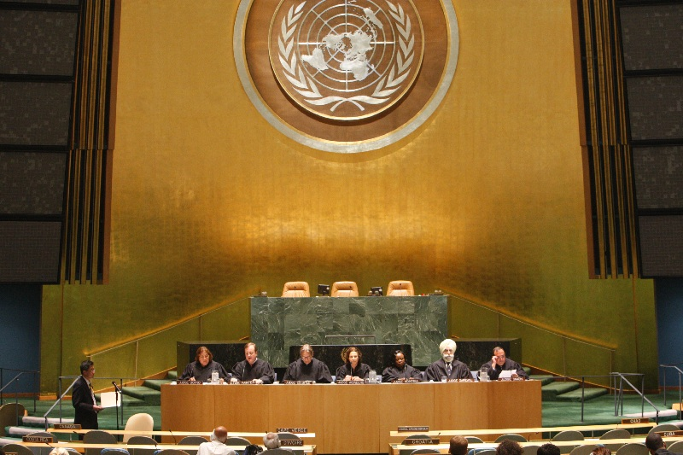
United Nations Appeals Tribunal announcing decisions in General Assembly Hall, New York, July1, 2010. Judges, from left: Rose Boyko (Canada), Mark P. Painter (USA), Jean Courtial, (France), Inés Weinberg de Roca, (Argentina), Sophia Adinyira, (Ghana), Kamaljit Singh Garewal (India), and Luis María Simón (Uruguay).
Judge Mark Painter of Cincinnati, the only American on the United Nations Appeals Tribunal, returned to Cincinnati after the court’s second session, held for two weeks in New York City. Its first session was in March in Geneva.
The court orally announced decisions on the cases July 1, in the General Assembly Hall. A synopsis of the decisions will be posted on the UN website later this month.
The UNAT is the highest court of the new internal-justice system, which was instituted in 2009 to provide access to independent and professional courts for staff members and management. The judges were elected by the General Assembly.
Cases included disputes over promotions, discipline, pensions, contract matters, and many other issues. These cases continue the development of the UN internal law.
As may be expected, the UNAT is internationally diverse. In addition to Painter, the Judges are Inés Weinberg de Roca, (Argentina), Jean Courtial, (France), Sophia Adinyira, (Ghana), Kamaljit Singh Garewal (India), Rose Boyko (Canada), and Luis María Simón (Uruguay).
Judge Painter served as a judge in Hamilton County for 27 years, 13 on the Municipal Court followed by 14 on the Court of Appeals.

More info: www.un.org/en/oaj/appeals
www.Judgepainter.org

####

